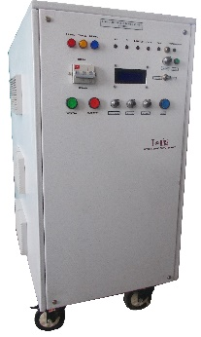
This high current pulsed generator was designed and developed for research purpose
HIGH CURRENT PULSED GENERATOR

5V, 2000A DC Pulsed

in Mechanical and Aerospace Engineering.

Features:
- Pulsed Output in Compact Unit
- Regulated
- Frequency & Duty Cycle Controllable
- OEM Customization Available

Technical Specifications
PARAMETER | SPECIFICATION
Input Voltage | 415V ±10% AC, 50Hz, three phase
Output Voltage (In Pulsed mode) | 5Vmax
Output Current Range | 0 to 2000A
Frequency Range | 0.2Hz to 100Hz variable
Frequency Control Range | Minimum to maximum of rated frequency range
Duty Cycle Control Range | 0 to 50% (10ms max)
Maximum Pulse ON Time | 1 to 10ms adjustable
Polarity | Positive
Mode of Operation | Pulsed. With a provision for single shot
Regulating Mode | Constant current
Regulation | ≤ 1%+IGBT drop
Controls  - Voltage  - Current  - Frequency  - Duty Cycle | By 10-turn potentiometers on the front panel
Waveform reading | Terminals provided to read the output voltage and current waveform
Protections | Against over load, short-circuit and arc
Front Panel | Mains ON/OFF switch  Power ON/OFF Switch  Single alphanumeric display for peak voltage, peak current, frequency and duty cycle  10 turn potentiometers for voltage, current, frequency & duty cycle control  Indications for 3 phase ON/OFF  Faulty indications  Push buttons for trip reset
Back Panel | Terminal block for 3 hhase mains input  Fuse holder with fuse  Buss bar terminals for high current output  Stud for grounding the unit
Topology | PWM-controlled switch mode
Regulating Device | IGBT
Cabinet | MS cabinet, powder coated

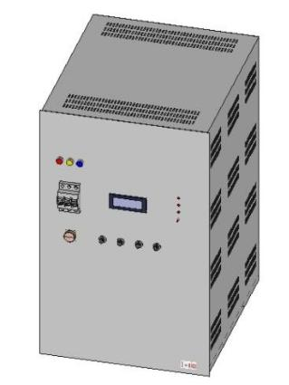
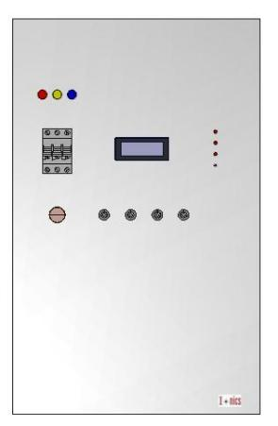
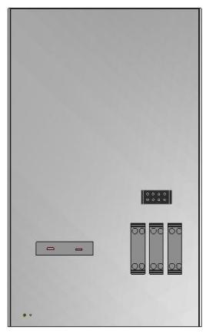

For any queries or customization requests contact us at info@ionics.co.in
For product line information visit us at www.ionics.co.in

